https://www.kaggle.com/datasets/omkarmb/dataset-open-access-vehicle-interior-sound-dataset/data - baza de date
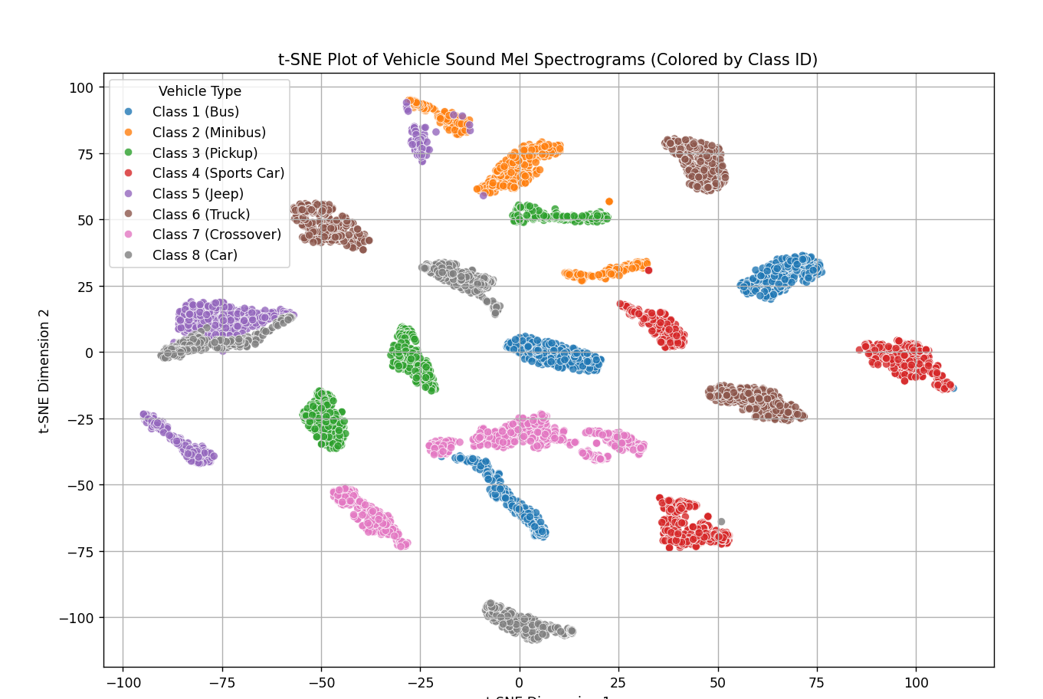
Impartire baza de date initial
-probleme la diferentiarea car/jeep – posibil motoare asemanatoare (Diesel) => acuratete mai mica in zona aceea

Training results after 20 epochs with no optimization

Training results after 20 epochs with optimization – much more robust, still some incertainties

### 1. Classification Report (Per-Class Performance) ###
precision recall f1-score support

Class 1 (Bus) 1.00 0.65 0.79 170
Class 2 (Minibus) 1.00 1.00 1.00 120
Class 3 (Pickup) 0.99 1.00 1.00 136
Class 4 (Sports Car) 1.00 0.99 1.00 160
Class 5 (Jeep) 0.98 1.00 0.99 120
Class 6 (Truck) 1.00 0.99 1.00 180
Class 7 (Crossover) 0.72 0.99 0.83 160
Class 8 (Car) 1.00 1.00 1.00 150

accuracy 0.95 1196
macro avg 0.96 0.95 0.95 1196
weighted avg 0.96 0.95 0.95 1196

### 2. Confusion Matrix (True vs. Predicted Labels) ###
True Labels (Rows) vs. Predicted Labels (Columns):
[[110 0 0 0 0 0 60 0]
[ 0 120 0 0 0 0 0 0]
[ 0 0 136 0 0 0 0 0]
[ 0 0 1 159 0 0 0 0]
[ 0 0 0 0 120 0 0 0]
[ 0 0 0 0 0 179 1 0]
[ 0 0 0 0 2 0 158 0]
[ 0 0 0 0 0 0 0 150]]
- Some busses are classsified as crossovers, we try incresing the number of bins in the mel spectrogram to 256 from 128.

### 1. Classification Report (Per-Class Performance) ###
precision recall f1-score support

Class 1 (Bus) 0.87 1.00 0.93 170
Class 2 (Minibus) 0.63 0.99 0.77 120
Class 3 (Pickup) 0.99 1.00 1.00 136
Class 4 (Sports Car) 1.00 0.99 1.00 160
Class 5 (Jeep) 1.00 0.97 0.99 120
Class 6 (Truck) 0.99 0.63 0.77 180
Class 7 (Crossover) 0.99 1.00 1.00 160
Class 8 (Car) 1.00 0.83 0.91 150

accuracy 0.92 1196
macro avg 0.94 0.93 0.92 1196
weighted avg 0.94 0.92 0.92 1196

### 2. Confusion Matrix (True vs. Predicted Labels) ###
True Labels (Rows) vs. Predicted Labels (Columns):
[[170 0 0 0 0 0 0 0]
[ 0 119 0 0 0 1 0 0]
[ 0 0 136 0 0 0 0 0]
[ 0 0 1 159 0 0 0 0]
[ 1 2 0 0 117 0 0 0]
[ 24 42 0 0 0 113 1 0]
[ 0 0 0 0 0 0 160 0]
[ 0 25 0 0 0 0 0 125]]
- Less dips in accuracy, but significantly more instable => we go back to 128 features and add more „bus” entries by pitch shifting or time stretching existing ones. (TO DO)
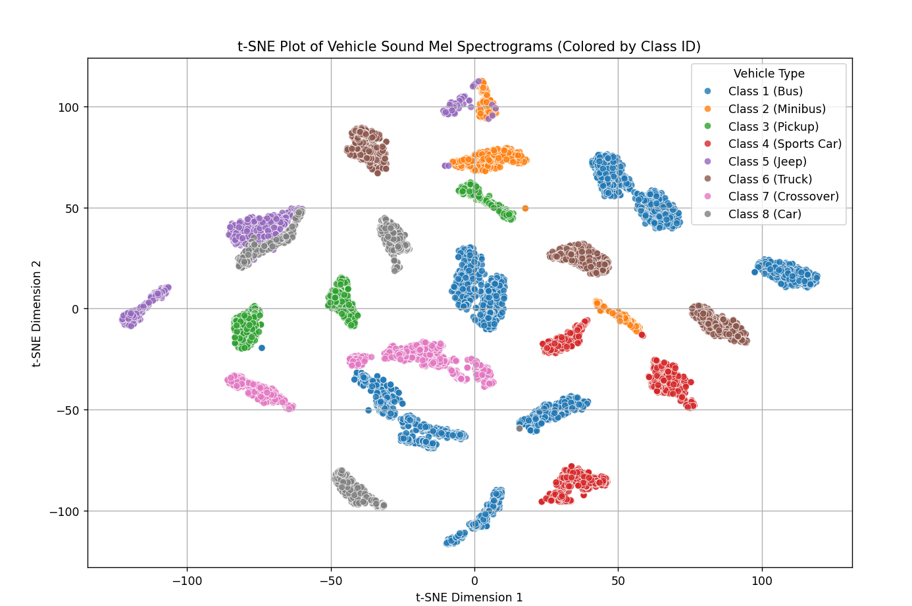
Increased number of bus sound queues by pitch shifting and adding noise to existing entries.
--- Final Results ---
Final Test Accuracy: 98.89%
Final Test Loss: 0.1402
---------------------
### 1. Classification Report (Per-Class Performance) ###
precision recall f1-score support

Class 1 (Bus) 1.00 1.00 1.00 510
Class 2 (Minibus) 0.99 0.92 0.95 120
Class 3 (Pickup) 1.00 1.00 1.00 136
Class 4 (Sports Car) 1.00 0.96 0.98 160
Class 5 (Jeep) 1.00 0.99 1.00 120
Class 6 (Truck) 1.00 1.00 1.00 180
Class 7 (Crossover) 0.96 1.00 0.98 160
Class 8 (Car) 0.94 1.00 0.97 150

accuracy 0.99 1536
macro avg 0.99 0.98 0.98 1536
weighted avg 0.99 0.99 0.99 1536

### 2. Confusion Matrix (True vs. Predicted Labels) ###
True Labels (Rows) vs. Predicted Labels (Columns):
[[510 0 0 0 0 0 0 0]
[ 0 110 0 0 0 0 0 10]
[ 0 0 136 0 0 0 0 0]
[ 0 0 0 154 0 0 6 0]
[ 0 1 0 0 119 0 0 0]
[ 0 0 0 0 0 180 0 0]
[ 0 0 0 0 0 0 160 0]
[ 0 0 0 0 0 0 0 150]]
=>better results

We’ll try a learning run with early stoppage (stop learning after a few stable epochs)
After settings an ealry stoppage of 8 epochs, and runnning for 50 the result is the following:
### Classification Report ###
precision recall f1-score support
Bus 1.00 1.00 1.00 510
Minibus 0.99 1.00 1.00 120
Pickup 1.00 1.00 1.00 136
Sports 1.00 1.00 1.00 160
Jeep 1.00 0.99 1.00 120
Truck 1.00 1.00 1.00 180
Crossover 1.00 1.00 1.00 160
Car 1.00 1.00 1.00 150

accuracy 1.00 1536
macro avg 1.00 1.00 1.00 1536
weighted avg 1.00 1.00 1.00 1536
which is an almost perfect score.

